the Performance of Open Government Data Platforms

**Thematic Analysis Report**

**Introduction**

Open Government Data (OGD) platforms are central to enhancing transparency, improving public services, and fostering innovation. As governments around the world strive to make their data more accessible, the performance of these platforms becomes a key concern. The ability to leverage technological innovations, maintain transparency, foster collaboration, and develop a robust framework for data analysis significantly impacts the success of these platforms. This report presents the results of a thematic analysis of interviews conducted with key stakeholders involved in the implementation and usage of OGD platforms. The primary aim is to identify the factors influencing OGD platform performance, explore the relationship between technological innovation and performance, discuss the challenges of adopting technological innovations, and propose best practices for leveraging technology to enhance platform performance.

The analysis was performed using NVivo, and the data extracted were categorized into five core themes: **Using of Technology**, **Transparency and Open Data Analysis**, **Innovation and Future Opportunities**, **Performance Measurement and Data Effectiveness**, and **Collaboration and Partnerships**. These themes are then explored in relation to the research questions posed in the study.

Thematic Framework

the thematic analysis revealed several significant patterns that inform the factors influencing the performance of OGD platforms. Below are the five key themes that emerged:

1. **Using of Technology**  
   Technology is an integral component in the functionality and success of OGD platforms. It facilitates data processing, management, and dissemination, making government data more accessible and actionable. Technologies like cloud computing, big data analytics, and artificial intelligence (AI) enhance the capacity of OGD platforms to process vast amounts of data, improve user experience, and foster innovation. The use of technology is not only a driver for the platform’s operational efficiency but also a foundation for future opportunities in data utilization and public service delivery.
2. **Transparency and Open Data Analysis**  
   Transparency is a critical element in OGD. Governments must ensure that the data they make available is not only accessible but also understandable and usable by the public. However, achieving full transparency is often hindered by challenges related to data privacy, security, and inconsistencies in data quality. The interviews highlighted that while there is an increasing push for transparency, many government agencies face significant barriers in sharing complete, consistent, and high-quality data.
3. **Innovation and Future Opportunities**  
   Technological innovations are key to the development of OGD platforms. Innovations such as AI, machine learning, and blockchain have the potential to transform OGD platforms by enhancing the way data is analyzed, visualized, and utilized. These technologies enable governments to offer more dynamic services, optimize decision-making, and provide citizens with customized information. Innovation presents new opportunities for enhancing the functionality of OGD platforms and aligning them with the evolving needs of the public and businesses.
4. **Performance Measurement and Data Effectiveness**  
   The effectiveness of OGD platforms is often measured by their performance in delivering accurate, timely, and relevant data to users. Performance metrics include the usability of the platform, user engagement, the accuracy of data, and the extent to which the platform meets the needs of the public and businesses. The effectiveness of data on these platforms is essential for supporting decision-making, improving public sector transparency, and enhancing the overall impact of government initiatives.
5. **Collaboration and Partnerships**  
   Collaboration is crucial to the success of OGD platforms. By collaborating with external stakeholders, including private companies, non-profit organizations, and academic institutions, governments can improve the quality and accessibility of their data. These partnerships facilitate the sharing of best practices, foster innovation, and allow for the integration of diverse technological solutions. Collaboration also ensures that the OGD platform remains relevant, efficient, and adaptable to changing needs.

**Application of the Theoretical Framework to Future Analysis**  
The identified themes will guide the next phase of analysis by structuring the approach to examining OGD platforms. Future analysis will assess how technological advancements, such as AI and big data, directly influence data usability and user experience. Transparency challenges, including data quality and privacy issues, will be critically evaluated to identify gaps and propose actionable solutions. Performance metrics will be used to benchmark the effectiveness of various OGD platforms, comparing their ability to meet user needs and drive decision-making. Additionally, the role of innovation in shaping future opportunities for OGD platforms will be explored, focusing on how emerging technologies enhance their functionality. Lastly, collaboration models will be analyzed to determine their impact on data accessibility and cross-sector engagement, ensuring a comprehensive evaluation of OGD platform dynamics.

Key Relationships Between Themes

The thematic analysis uncovered significant relationships between the themes that impact the performance of OGD platforms. These relationships highlight the interconnectedness of technology, collaboration, innovation, transparency, and performance measurement.

| Name | Description |
| --- | --- |
| Challenges that hinder achieving transparency | Difficulties and problems facing data credibility |
| Collaboration (Improves) Performance Measurement | Cooperation between different sectors improves the transfer, performance and sharing of data |
| Technology Supports Innovation | Technology is always a stable and constant support for innovation and exploitation of available independent opportunities |

**1. Collaboration Improves Performance Measurement**  
Collaboration is essential for improving performance measurement in OGD platforms. When different stakeholders collaborate—whether it be between government departments, private companies, or international organizations—they contribute to a more comprehensive and accurate understanding of the platform’s effectiveness. Collaboration enhances data sharing, improves data quality, and fosters a collective approach to defining key performance indicators (KPIs) that are meaningful and actionable.

**2. Challenges in Achieving Transparency**  
Transparency in OGD platforms is often impeded by various challenges. One of the major obstacles is **data privacy**. Governments must balance the need for transparency with the protection of sensitive information. Additionally, the **inconsistency in data quality** between different agencies can hinder the accessibility and usability of open data. **Regulatory challenges** also affect the level of transparency, as certain data cannot be shared due to legal or policy restrictions. Addressing these challenges is essential for improving the performance and impact of OGD platforms.

**3. Technology Supports Innovation**  
Technological innovation plays a critical role in enhancing the capabilities of OGD platforms. Advanced technologies such as AI and machine learning enable governments to analyze large datasets, identify patterns, and make data-driven decisions. These technologies also provide the infrastructure for real-time data processing, improving the responsiveness of government services. By integrating these technological solutions, OGD platforms can evolve to meet the growing demands for more innovative and user-centric services.

**Research Questions and Thematic Analysis**

**1. What factors influence the performance of open government data platforms?**

The performance of OGD platforms is influenced by several factors:

* **Technological Adoption**: The effective use of advanced technologies such as AI, cloud computing, and data analytics enhances the functionality of OGD platforms.
* **Data Quality**: The consistency, accuracy, and standardization of data play a crucial role in the success of these platforms. High-quality data ensures that users can rely on the information provided.
* **Government Collaboration**: Collaboration between various government agencies and external stakeholders is crucial to ensure that OGD platforms meet the needs of the public.
* **Transparency and Data Accessibility**: The openness and accessibility of data, combined with clear communication of its meaning and relevance, are essential for the platform’s success.

**2. What is the relationship between the performance of open government data and technological innovation?**

* Technological innovation directly impacts the performance of OGD platforms. Innovations such as AI, machine learning, and blockchain enable platforms to process data more efficiently, offer personalized services, and enhance public sector transparency. These innovations improve the overall user experience, increase the usability of data, and support better decision-making by government agencies.

**3. What are the challenges to adopting technological innovation in open government data?**

Several challenges hinder the adoption of technological innovation in OGD:

* **Data Privacy and Security Concerns**: Governments must ensure that the data shared does not violate privacy regulations or put sensitive information at risk.
* **Infrastructural Limitations**: Some governments lack the necessary infrastructure to support advanced technological solutions.
* **Bureaucratic Resistance**: Organizational inertia and resistance to change can delay the adoption of new technologies.
* **Legal and Regulatory Constraints**: Data-sharing regulations and laws can create barriers to the full adoption of technological innovations.

**4. What framework can be developed to examine the influence of these factors on the performance of open government data?**

A framework for evaluating the influence of these factors could be structured around:

* **Technology Integration**: The adoption and integration of advanced technologies.
* **Data Accessibility and Quality**: The quality of data and how easily it can be accessed by the public.
* **Collaboration and Partnerships**: The role of various stakeholders in ensuring the success of OGD platforms.
* **Performance Metrics**: KPIs that measure the effectiveness of OGD platforms in achieving transparency, efficiency, and public engagement.

**5. What are the best practices for leveraging technological innovation to enhance the performance of open government data?**

Best practices include:

* **Adopting Emerging Technologies**: Governments should embrace AI, machine learning, and cloud computing to improve data analysis and service delivery.
* **Fostering Collaboration**: Collaborating with external stakeholders helps bring innovative solutions and ensures that OGD platforms remain relevant and effective.
* **Improving Data Quality**: Ensuring that data is accurate, complete, and standardized is vital for the success of OGD.
* **Investing in Infrastructure**: Robust IT infrastructure is essential for supporting technological innovations and ensuring that OGD platforms function efficiently.

**Results of the Overall Analysis**

* The analysis of the interview data using NVivo software revealed significant insights into the factors influencing the performance of Open Government Data (OGD) platforms. The thematic analysis process allowed for a deeper understanding of the various elements impacting these platforms and how technological innovations and collaborations are interwoven in shaping their success.
* A critical finding from the analysis was the prominent role that **collaboration** plays in enhancing the performance measurement of OGD platforms. Interviews highlighted that when government agencies, private sector partners, and civil society organizations collaborate, they are better equipped to share data, innovate solutions, and address public needs. This partnership-driven approach creates a dynamic ecosystem where open data can be leveraged more effectively, ensuring that platforms do not just collect data but actually transform it into valuable insights.
* The **use of technology** was another central theme that emerged from the analysis. Technological innovations such as AI and machine learning were frequently mentioned as game-changers for OGD platforms. Participants noted that these technologies significantly improved the processing and analysis of data, allowing governments to provide more timely and accurate information to the public. However, it was also clear that the adoption of new technologies is hindered by several challenges. These include **data privacy concerns**, which remain a significant barrier to implementing more advanced technological solutions, especially those involving personal or sensitive data.
* Additionally, the analysis highlighted that **transparency and openness** are not just desired but essential for the success of OGD platforms. The open sharing of data fosters trusts between the government and the public. However, the findings also revealed that there are still many challenges that need to be addressed to achieve full transparency. Participants identified issues such as inconsistent data quality, bureaucratic barriers to data sharing, and the lack of a standardized approach to data governance as major obstacles.
* The relationship between **technological innovation** and the performance of OGD platforms was also explored in detail. It became evident that technology acts as a catalyst for improving the accessibility and utility of government data. However, the extent to which technology can drive performance depends largely on the readiness of the government infrastructure to embrace and integrate new tools. In some cases, outdated systems and resistance to change slowed down the pace of innovation and data sharing.
* The framework that emerged from this analysis is designed to address these challenges while capitalizing on the strengths of collaboration and technology. It suggests a more integrated approach where data governance, technological advancements, and collaboration are considered interdependent. It is clear that for OGD platforms to thrive, they must evolve into more than just data repositories; they must become hubs for innovation and active engagement with various stakeholders.

Visualizations

The bar chart above represents the distribution of participants based on their job titles. It highlights the diversity of professional backgrounds among the interviewees, providing insight into the range of perspectives on open government data and technological innovation.

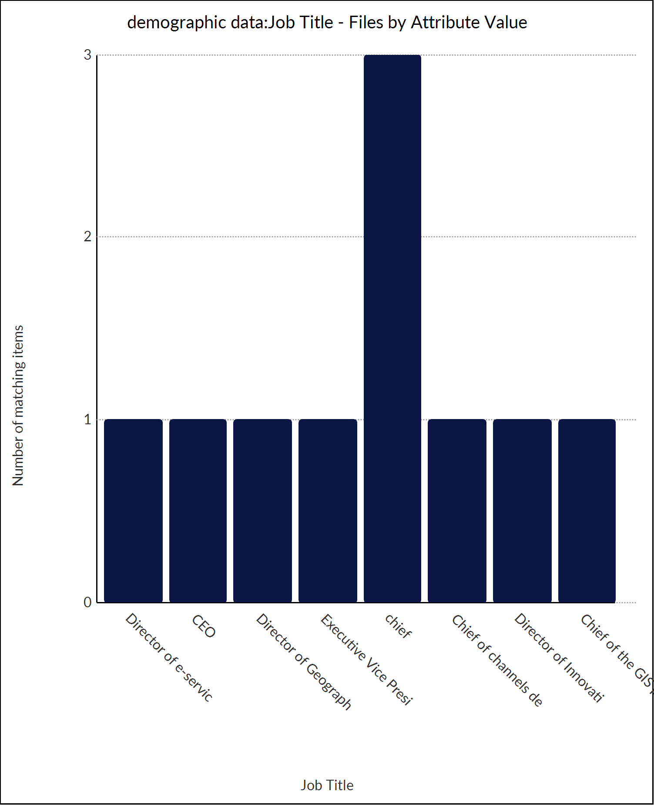

The

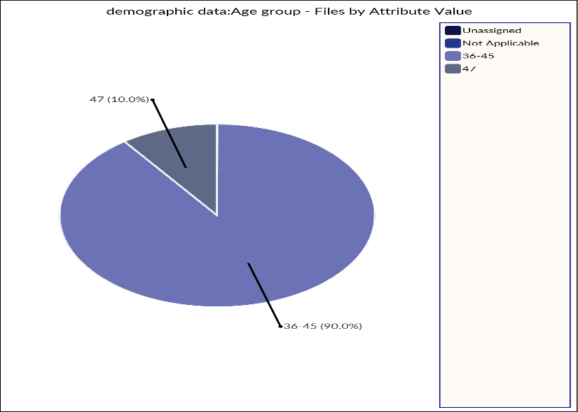

The pie chart illustrates the age group distribution of the participants. It provides a clear visual representation of how different age groups contributed to the discussions on technology, innovation, and data effectiveness in open government platforms.

chart shows the correlation between job titles and the level of support for technology in the development of open government data. The results indicate a strong alignment between senior roles and the advocacy for technological advancements.

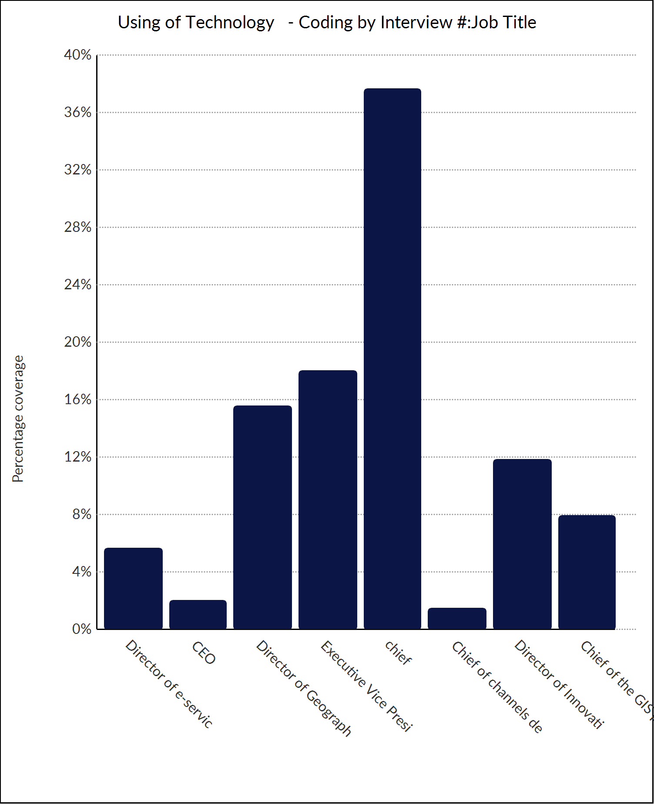

**Conclusion**

This study highlighted the critical role of technology, transparency, collaboration, and innovation in enhancing the performance of open government data platforms. Key findings indicate that technological advancements, such as AI and data analytics, are crucial for optimizing data management and responsiveness. Transparency fosters trust and promotes greater data utilization, but challenges in data accessibility and governance remain. Collaboration between government and private sectors is vital for success, though it is hindered by bureaucratic barriers. Performance measurement is essential for tracking the success of these platforms, but standardized frameworks are still lacking. Overall, while challenges exist, the integration of innovation holds great potential for transforming open government data systems.